Social Media - Acceptable Use Agreement
This Agreement is to be read by parents/carers and the young person, in order to ensure the obligations are understood before signing.
Hinckley Ladies Netball Club understands the importance of and need for the responsible use of social media and their responsibility for helping to safeguard young people in the sport of netball.
We ask all members, parents and people in positions of trust to read the England Netball Social Media Policy and ensure that they, their child or the young people in their association have understood the importance of the Policy and the expectations on them in relation to their use of social media.
I understand that:-
- I am responsible for my behaviour when using social media and texts relating to a member, connected participant or employee of England Netball and the sport of netball, including anything re-posted and my use of language;
- I have read and understand the England Netball Social Media policy and understand that I may be subject to Disciplinary Action should I breach its usage guidance;
- I understand that my use of the internet and social media sites through _{…………………….………… (}insert name of club) can be monitored and logged and made available to the club and England Netball and any external agencies involved with the regulation of internet usage;
- I will not post or give out any personal details, such as name, address, age and contact numbers, either of myself or any other person; *
- I will not share my own or the club password with anyone;
- I will not arrange to meet anyone without the knowledge and consent of my parent/carer;
- I will not deliberately browse, download, access or post any material that could be offensive, threatening or illegal;
- I agree to report material, posts or contacts which I find upsetting or cause me concern;
- I understand that if there is need for anyone to take action as a result of my use of social media in the sport of netball, my parent/carer may be contacted.

I …………………………………………. have read and discussed this policy and I agree to support the safe use of social media at Hinckley Ladies Netball Club.

Over 18’s Signature and date:
Members signature: |  | Date:

If under 18 on 1 September of the current year, the following must also be signed by a Parent or Guardian:

Parent/Carer’s name: |  | Parent/Carer’s Signature
Young person’s name: |  | Young Person’s Signature
Date:
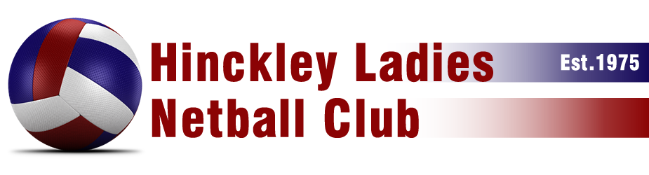
Performance Athletes may have a personal page/identify which relates to their netball play and consequently their identity will be known. They are reminded of the need not to provide additional personal details, whether of their own or another person, which could create a risk to themselves or another person.

