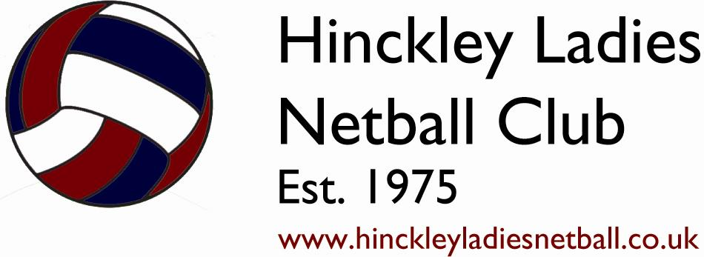

Hinckley Ladies Netball Club
Registration Form

Please complete and sign this form where appropriate. Please note that no information will be passed onto third parties without your consent, however if you are affiliated to England Netball, your details will be forwarded to their membership department. Relevant details of any medical conditions you have will be made available to HLNC team captains, umpires and coaches for your safety and protection. HLNC makes no assurances regarding the storage of data which is not in its custody and disclosed to third parties, however these forms will be stored securely and destroyed at the end of the current season.

Personal Details (to be completed by ALL members)
Full name:
(for reg purposes)
Title: |  | D.O.B:
Address:
Postcode: |  | Mobile:
Email:

ICE (In Case of Emergency - to be completed by ALL members – please complete a minimum of one contact)
Emergency  contact name: |  | Mob/Tel:
Emergency  contact name: |  | Mob/Tel:

Medical Declaration (to be completed by ALL members)
Please state if you suffer from any medical condition that we may need to be aware of which could affect you at any time:

Asthma | Yes / No |  | Crohn’s disease | Yes / No | Head injuries |  | Yes / No
Allergies | Yes / No |  | Diabetes | Yes / No | Heart conditions |  | Yes / No
Bleeding disorders | Yes / No |  | Epilepsy | Yes / No
Other
If you answered yes to any of the above, is the condition under control? |  |  |  |  |  | Yes / No
Do you need to have medication with you? |  |  |  |  |  | Yes / No
If you answered yes to the above, in what form is the medication taken?
Are you allergic to any form of wound dressing (plasters) etc that may be found in a basic First Aid kit? If so, please state: |  | PTO

Disability (to be completed by ALL members)
HLNC is an inclusive club and we do not discriminate against players with disabilities. To allow us to accommodate your needs where possible, please complete the following:

Do you regard yourself as disabled? | Yes |  | No

If you have answered yes to the above, please give further details of your impairment below

Learning disability |  | Hearing impairment |  | Visual impairment

If you have an impairment that is not listed, please state

Equity Statement (to be completed by ALL members)
HLNC respects the rights, dignity and worth of every person and will treat everyone equally within the context of their sport, regardless of age, ability, race, ethnicity, religious belief, sexuality or social/economic status. HLNC is committed to everyone having the right to enjoy their sport in an environment free from threat and intimidation, harassment and abuse. All club members have a responsibility to oppose discriminatory behaviour and promote equality of opportunity. HLNC will deal with any incidence of discrimination seriously, according to the club disciplinary procedures.

I, ___________________________________________________ have read and understood this form and have completed to the best of my ability.

I will commit to HLNC training sessions, match fixtures (if selected for a team), and will support social events and fundraising within the club. I understand my club and fellow members will show the same commitment and I will aim to progress as a netballer for myself and the Club. I shall adhere to the Club’s Code of Conduct and play to England Netball rules. I will not bring myself, others, or the Club into disrepute.

Members signature: |  | Date:

Juniors (to be completed UNDER 18’s only)
If under 18 on 1 September of the current year, the following must be signed by a Parent or Guardian

PARENTS PLEASE READ & COMPLETE THE FOLLOWING:
I confirm I have read and completed the medical section correctly

I confirm that I allow my daughter to travel with nominated drivers in the course of transportation to and from matches and training
I consent to my daughter participating in both training sessions and/or league matches.

I consent to team and match photos which include my daughter to be used on the club website and for media purposes (ie: match reports)

Daughters school year as of 1 September of the current year | Year

Parents signature: |  | Date:

* * * * * * * * * * * * * * *
To be completed by HLNC Membership Secretary
EN Reg |  |  |  |  |  | Season
Status | Non player | Training | Playing
Senior | A | B | C | D | E | F | G | Hornettes
Junior | U12 | U13 | U14 | U16

