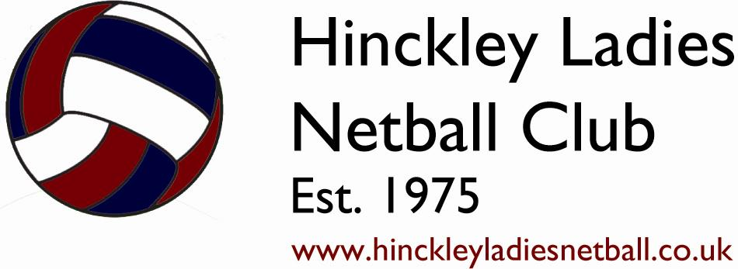
CONSTITUTION
Hinckley Ladies Netball Club
Version 8
[Amended 15.08.2014]

1. | Names | ………………………………………………………………………………………………………………..… |  |  |  |  |  |  |  |  |  | 2
2. | Aims and Objectives |  |  |  |  |  |  | ………………………………………………………………………………………….. |  |  |  | 2
3. | Equity Statement |  |  |  |  | ……………………………………………………………………………………………….. |  |  |  |  |  | 2
4. | Membership |  |  |  | ………………………………………………………………………………………………………… |  |  |  |  |  |  | 2
5. | Membership Fees |  |  |  |  | …………………………………………………………………………………………….... |  |  |  |  |  | 3
6. | Officers of the Club |  |  |  |  |  | ……………………………………………………………………………………………… |  |  |  |  | 3
7. | Committee |  |  |  | …………………………………………………………………………………………………………. |  |  |  |  |  |  | 3
8. | Finance |  | ………………………………………………………………………………………………………………... |  |  |  |  |  |  |  |  | 4
9. | Annual General Meetings |  |  |  |  |  |  |  |  | …………………………………………………………………………………….. |  | 4
10. | Discipline and Appeals |  |  |  |  |  |  |  | …………………………………………………………………………………………. |  |  | 4
11. | Dissolution |  |  | ……………………………………………………………………………………………………………. |  |  |  |  |  |  |  | 5
12. | Amendments to the Constitution |  |  |  |  |  |  |  |  |  | ………………………………………………………………………. | 5
13. | Declaration |  |  | ……………………………………………………………………………………………………………. |  |  |  |  |  |  |  | 5

“Our mission is to provide an environment that promotes netball for participation, competition and fun for all within the local community regardless of age, ethnic origin, race or ability”

- Names
  - The Club will be called HINCKLEY LADIES NETBALL CLUB (HLNC) and will be affiliated to ENGLAND NETBALL (EN)
- Aims and Objectives
  - The aims and objectives of the Club will be:
    - To offer coaching and competitive opportunities in netball
    - To promote the Club within the local community
    - To ensure a duty of care to all members of the Club
    - To ensure that all present and future members receive fair and equal treatment
    - To co-operate with any league(s) in which HLNC is participating, ie:
COVENTRY AND WARWICKSHIRE NETBALL ASSOCIATION (CWNA), to
promote and encourage the game of netball
    - To adopt the rules and regulations laid down by the EN and the league(s)
in which HLNC are participating in (as per 2.1.5)
    - To deploy the funds of HLNC as shall be deemed to be in the best interests
of its members
- Equity Statement
  - The Club (HINCKLEY LADIES NETBALL CLUB) is committed to ensuring that equity is incorporated across all aspects of its development. In doing so, it acknowledges and adopts the following Sport England definition of sports equity:
“Sports equity is fairness in sport, equality of access, recognising inequalities and taking steps to address them. It is about changing the culture and structure of sport to ensure it becomes equally accessible to everyone in society”
  - The Club respects the rights, dignity and worth of every person and will treat everyone equally within the context of their sport, regardless of age, ability, gender, race, ethnicity, religious belief, sexuality or social/economic status.
  - The Club is committed to everyone having the right to enjoy their sport in an environment free from threat of intimidation, harassment and abuse.
  - All Club members have a responsibility to oppose discriminatory behaviour and promote equality of opportunity
  - The Club will deal with any incidence of discriminatory behaviour seriously, according to Club disciplinary procedures.
  - The Club will promote the inclusion of disability where reasonable within the relevant league regulations and rules.
- Membership
  - Membership will consist of officers and members of the Club
  - All members will be subject to the regulations of the Constitution and by joining the Club will be deemed to accept these regulations and Codes of Conduct that the Club has adopted
  - Members shall be enrolled in one of the following categories:
    - Full member (+18)
    - Full member (-18)
    - Social member (non playing member/coach/umpire)
    - Student member (over 16 but still in full-time education)
    - Junior member (U16 playing member)
    - Life member (membership of 25 years or more)
    - Honorary member (exceptional service to the club)
- Membership Fees
  - Membership fees for senior and junior players will be set annually and agreed by the Executive Committee to incorporate the EN affiliation cost and the relevant leagues’ registration fees. These will be published separately before the start of each season.
  - Fees for weekly training will be paid by monthly standing order as agreed by the Treasurer. Subs will be collected by order of the committee. Social members will have the option to pay by monthly standing order or by weekly subscription.
  - Match day subs are included in the monthly standing order and covers the running costs of the club and the umpires fee.
  - All membership fees are subject to change at any point and will be reviewed by the Executive Committee before the start of every season.
- Officers of the Club
  - The Executive Officers of the Club will be:
    - Chair
    - Vice Chair
    - Membership & General Secretary
    - Treasurer
    - Juniors Representative
    - Coaching Manager
    - Fixtures & Umpiring Secretary
    - Performance Manager
    - Sponsorship & Grants Secretary
    - Facilities Manager
  - The Non-Executive Officers of the Club will be determined by the Executive Committee as required based upon the needs of the Club
  - Executive Officers will be elected bi-annually at the AGM. Subject to officers wishing to retire, all Executive Officers will hold the position for two years and then retire or be re-elected.
  - Non-Executive Officers will be elected annually at the AGM. All Non-Executive Officers will hold the position for one year and then retire or be re-elected
- Committee
  - The Club will be managed through the Executive Committee consisting of the Officers of the Club
  - The Executive Committee will be convened by the Chairperson of the Club and will hold no less than four meetings per year.
  - All Executive Officers will be required to be in attendance at all meetings with Non-Executive Officers invited or as required when they have business or matters arising.
  - The quorum required for business to be agreed at the Executive Committee meetings will be 51% of the attendees of any meeting.
  - The Executive Committee will be responsible for adopting new policy, Codes of Conduct and rules that affect the organisation of the Club
  - The Executive Committee will have powers to appoint sub-committees as necessary and appoint advisers to the Executive Committee as necessary to fulfil its business.
  - The Executive Committee will be responsible for disciplinary hearings of members who infringe the Club rules/regulations/Constitution. The Executive Committee will be responsible for taking any action of suspension or discipline following such hearings.
  - Neither Chairperson or Vice Chairperson will hold the position of captain in any team to ensure impartiality to any matters arising, including disputes and disciplinary matters (as per Section 10: Disciplinary and Appeals)
- Finance
  - All Club monies will be banked into an account held in the name of the Club.
  - The financial year of the Club will end at the close of every netball season (AGM)
  - A statement of annual accounts will be presented by the Treasurer at the Annual General Meeting (AGM).
  - Any cheques drawn against Club funds should hold the signatories of two nominated officers.
- Annual General Meetings
  - Notice of the AGM will be given by the Membership & General Secretary. Not less that 21 clear days notice to be given to all members.
  - The AGM will receive a report of the Executive Committee and a statement of the audited accounts.
  - Nominations for officers of the Executive Committee will be sent to the Membership & General Secretary prior to the AGM.
  - Elections of Officers are to take place at the AGM.
  - All members who attend the AGM, and are over the age of 16 or are playing in a senior league, have the right to vote at the AGM. There will be no voting by proxy
  - All motions passed at the AGM will stand until the next AGM or any EGM in the meantime.
  - The number of members present for the AGM, will be no less than 25% of the membership of the Club, who are eligible to vote (see 9.5)
  - The Executive Committee has the right to call Extraordinary General Meetings (EGM) outside of the AGM. Procedures for an EGM will be the same as for the AGM.
  - A provisional date for the following years AGM will be set as the final agenda point at each AGM
- Discipline and Appeals
  - All complaints regarding the behaviour of members should be submitted in writing to the Chairperson
  - The Executive Committee will meet to hear complaints within 14 days of a complaint being lodged. The Executive Committee has the power to take appropriate disciplinary action including the termination of membership.
  - The outcome of a disciplinary hearing will be notified in writing to the person who lodged the complaint and the member against whom the complaint was made within 14 days of the hearing.
  - There will be the right of appeal to the Executive Committee following disciplinary action being announced. The Executive Committee should consider the appeal within 14 days of the Membership & General Secretary receiving the appeal.
  - Any instances of bullying being discovered within the Club by senior or junior members, will be taken very seriously. Any form of verbal, written and electronic bullying along with inappropriate behaviour within Club time, will be bought before the Executive Committee and may be subject to disciplinary measures. The publication of names, addresses, ages and schools of any U18 members of the Club will be seen as misconduct and all parties will be subject to disciplinary action by the Executive Committee.
- Dissolution
  - A resolution to dissolve the Club can only be passed at an AGM or EGM through a majority vote of the membership.
  - In the event of dissolution, any assets of the Club will remain the property of England Netball
- Amendments to the Constitution
  - The Constitution will only be changed through agreement by majority vote at an AGM or EGM.
- Declaration
  - Hinckley Ladies Netball Club hereby adopts this Constitution as a current operating guide regulating the actions of its members.

SIGNED: ………………………………………………………………………… DATE: …………………………………………
Name: ……………………………………………………………………………………………………………………………………
(Chair)

SIGNED: ………………………………………………………………………… DATE: …………………………………………
Name: ……………………………………………………………………………………………………………………………………
(Membership & General Secretary)

